

**Walchand College of Engineering ,sangli**

**(An Autonomous Institute )**

Department of Computer Science and Engineering

Project Synopsis on:

**Finger Knuckle Based Biometric Identification of person**

Submitted By:

Sagar Mhantati[2016BTECS00031]

Atharva Kango [2016BTECS00044]

Nikita Aware [2016BTECS00107]

Under guidance of:

Mr. Swapnil Mahadeshwar

**ABSTRACT**

This paper presents a new biometric identifier, namely finger-knuckle-print (FKP), for personal identity authentication. First a specific data acquisition device is constructed to capture the FKP images, and then an efficient FKP recognition algorithm is presented to process the acquired data. The local convex direction map of the FKP image is extracted, based on which a coordinate system is defined to align the images and a region of interest (ROI) is cropped for feature extraction.

Then those images where converted into their negatives followed by application of PCA for feature extraction. When matching, the angular distance is used to measure the similarity between two competitive code maps. An FKP database was established to examine the performance of the proposed system, and the experimental results demonstrated the efficiency and effectiveness of this new biometric characteristic.

**TABLE OF CONTENTS**

1 Introduction 7

1.1 Broad Area 7

1.2 Title of Project 7

1.3 Motivation 7

2 Literature survey 9

3 Problem Statement 9

4 Significance 9

4.1 Advantages over previous systems 9

4.2 Results of Project implementation 9

5 Objective 9

6 Methodology 9

7 Implementation 10

8 Conclusion 19

9 Reference 19

**1. INTRODUCTION**

**1.1 Broad Area**

1]Image processing.

2]Non-relational database(Firebase)

**1.2 Title of Project**

Finger Knuckle Based Biometric Identification of person

**1.3 Motivation**

- Finger knuckle print can be incredibly beneficial for person identity. FKP as a new biometric modality supplying huge scope for researchers in few years. In this system we present a finger knuckle identification method that uses subspace techniques. In proposed system we use the three subspace techniques, first we use Gabor filter in preprocessing for removing the noise from acquired image and we get the noise free image. Secondly we use PCA for feature extraction and then last we use the LDA as well as Knn classifier for matching purpose. Result obtained from knn classifier and LDA algorithm gives the approximately 98% recognition rate. Also gives the high efficiency as compare to other methods.

**2. Literature Survey**

1. <https://www.researchgate.net/publication/226344961_An_Introduction_to_Biometric_Authentication_Systems>
2. <https://ieeexplore.ieee.org/document/5413734>

**3. Problem Statement**

Finger Knuckle Based Biometric Identification of person i.e. identifying a person on the basis of Finger Knuckle Print, which is also the unique biometric of human body.

**4. Significance**

**4.1 Advantages over previous systems**

Previous systems were using fingerprint data for identification of the person which made them prone to manipulation on the other hand knuckle data is difficult to manipulate.

**4.2 Results of Project implementation**

1]Identification of the person by using finger knuckle data with optimum accuracy.

**5. Objectives**

The main Objective of this project is to design system which will use finger knuckle data for identification of the person.

**6. Methodology**

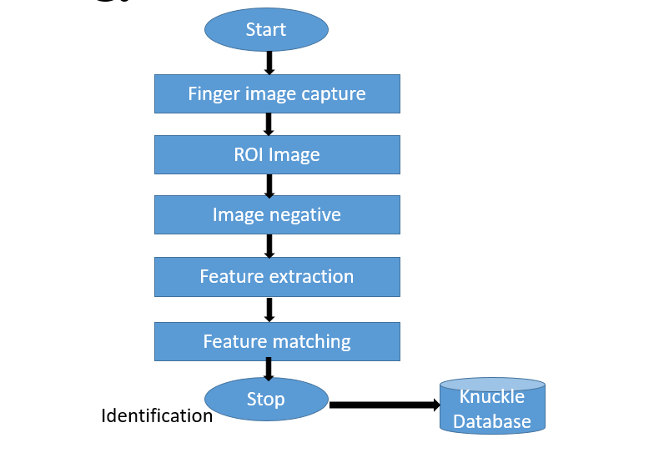

* First of all we took different images of finger at same angle.
* The second step followed by this is region of interest extraction to get dataset in required format.
* Next to that we converted that image into its Negative.
* For feature extraction we applied PCA i.e. Principal Component Analysis on image negative.
* Then we used KNN classifier .

**5]Performance**

Overall accuracy obtained till date is about 80-85%. As the project involves image processing in OpenCV using python, the exact accuracy can’t be calculated. Various factors such as light conditioning, camera quality, etc. affect on the accuracy as well.

**7. Implementation**

Following are the images of finger knuckle at different stages.

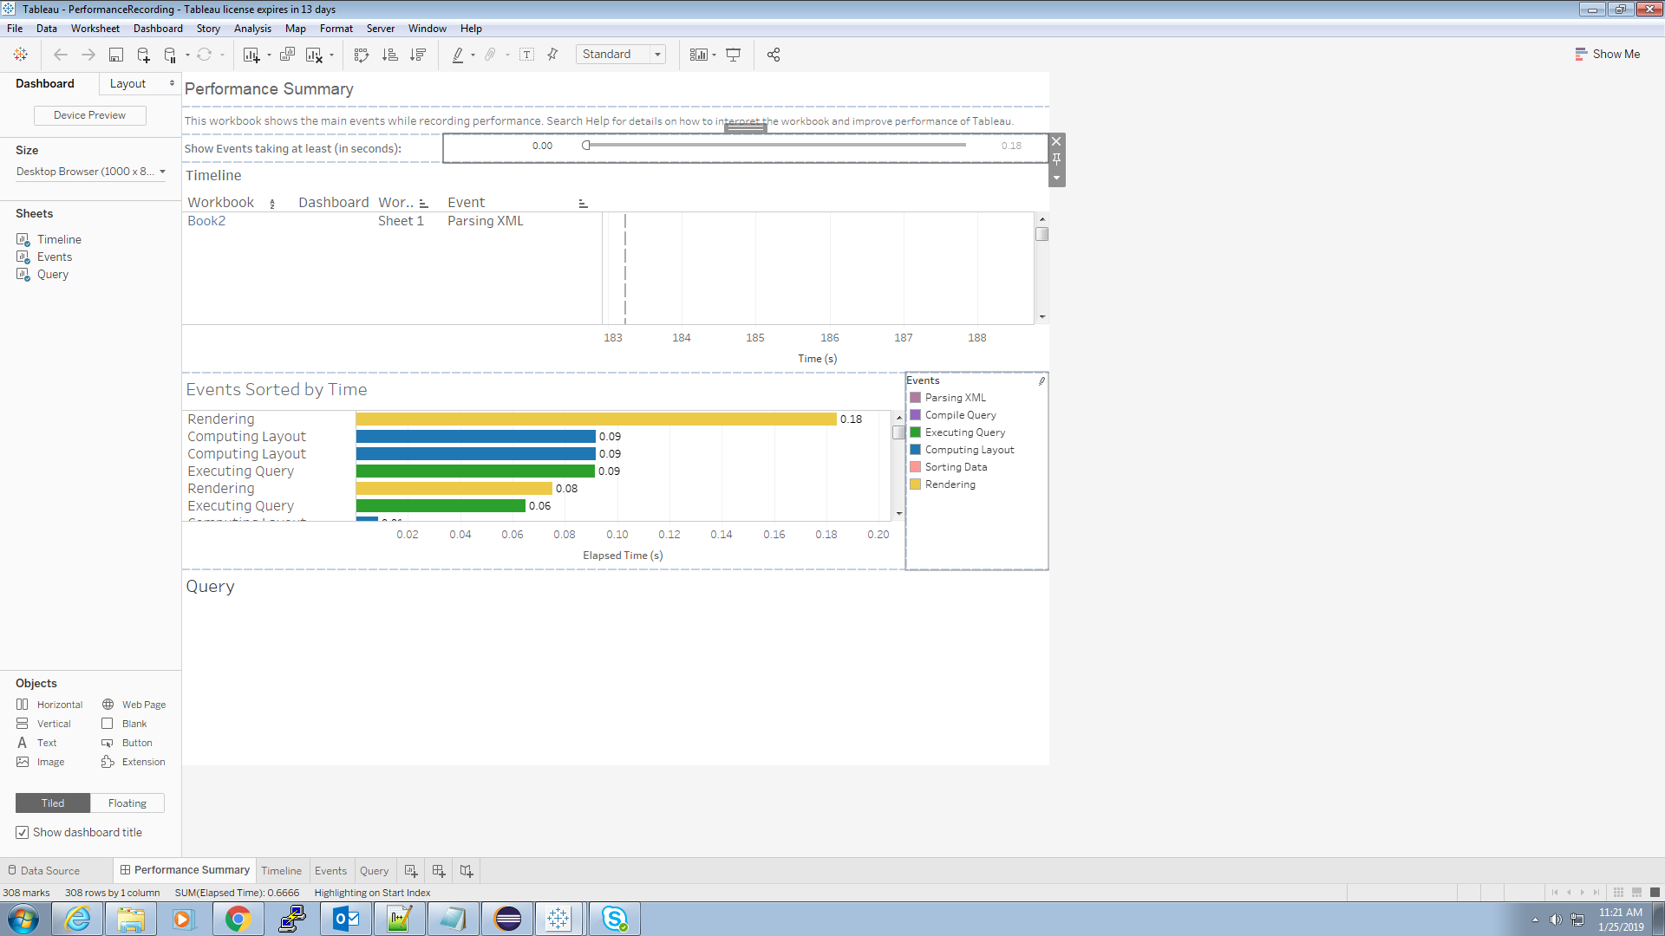

**8. Conclusion**

This project has presented a new approach of subspace technique for personal authentication using finger knuckle back surface. This system compares the user knuckle with the database knuckle from the captured knuckle by using web camera, the contour part of two images.

**9.**  **Reference**

* Kyi Pyar Zaw, Aung Soe Khaing, “Implementation of Contactless Finger Knuckle Identification System,” IJSETR, vol. 3, Issue 6,June 2014. (references)
* Shubhanda Sonawane, Verifying Human Identities Using Major and Minor Finger Knuckle Pattern, vol.5, Issue2, Feb 2016.
* D. L. Woodard, P. J. Flynn, “Finger surface as a biometric identifier”, Computer Vision and Image Understanding, pp. 357-384, vol. 100, Aug. 2005.